**Experiment 6: Preparation of Tin Oxide by Sol-gel Method and its Characterization**

**Name:** Vidhi Shah

**Reg. No.:** 21BCE1297

**Slot:** L11-L12

**Date:** 16/11/21

**XRD pattern of SnO2 nanoparticles mediated in methanol (a), ethanol (b), and water (c).**

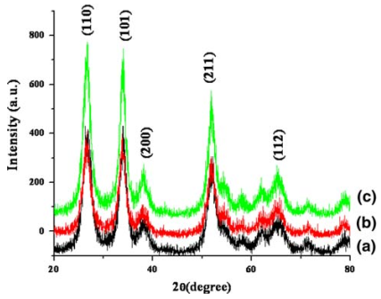

**Analysis:**

The powder XRD peak positions for the prepared SnO2 nanoparticles by sol-gel method are identified based on standard JCPDS file #__88-0287. This shows the tin oxide crystallizes in tetragonal crystal system **(110) peak – 27 o, (101) peak – 34 o, (200) peak – 38 o,**

**(211) peak – 52 o, (112) peak – 65 o**.

**Calculation for the determination of crystallite size of SnO2 NPs using Scherrer’s equation:**

Suppose, two peaks appeared in the diffractogram as

i) (110) peak has 2θ = 26.9169o and FWHM = 2.6468o

ii) (101) peak has 2θ = 33.9169o and FWHM = 1.8303o

Crystallite size of SnO2 NPs can be calculated by using Scherrer’s equation as follows:

**Crystallite size = ${kλ}/{(βCosθ)}$ nm**

where, k = 0.9, λ = 0.15406 nm,

β = FWHM in radian, 2θ = Bragg’s angle in degree

For this calculation,

You should change 2θ to θ by dividing 2 and FWHM value in degree should be converted to radian by multiplying a factor of π*180.

**i) for (110) peak**:

2θ = 26.9169o,

θ = 26.9169o/2 = 13.4584o,

cos(13.4584) = 0.972539159,

FWHM = 2.6468o = = 0.0461953746 radians

Crystallite size = **3.086 nm**

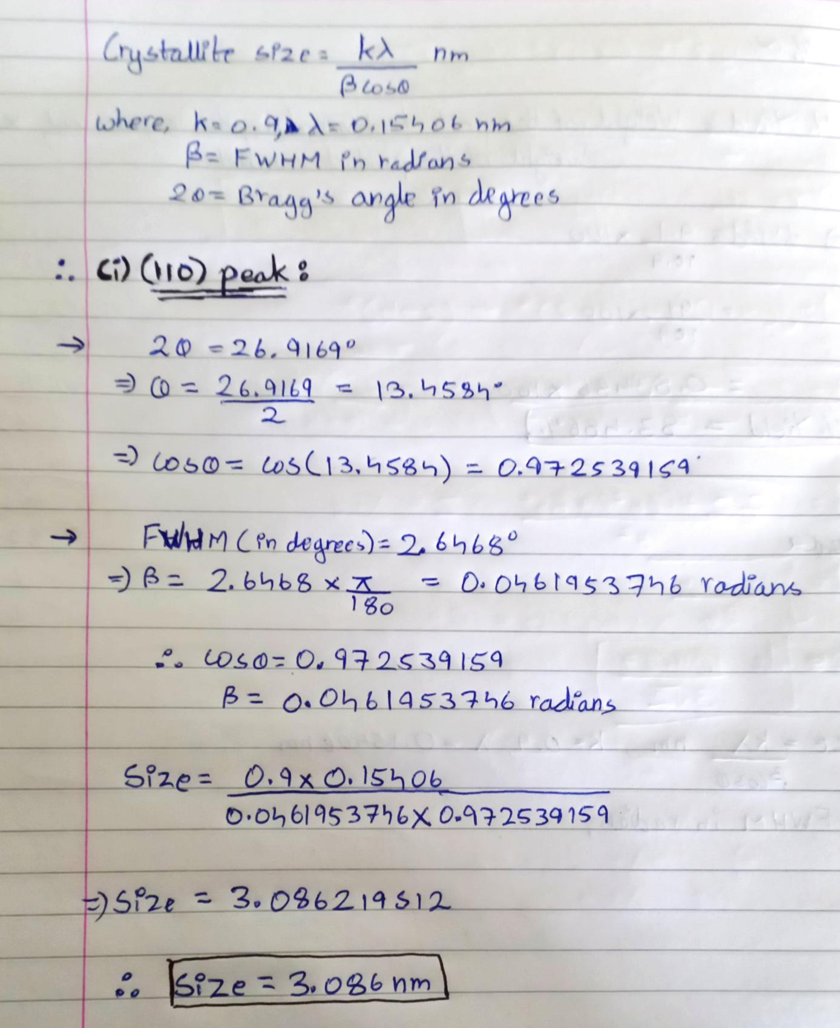

**ii)** **for (101) peak:**

2θ = 33.9169o,

θ = 33.9169o/2 = 16.9584o,

cos(16.9584) = 0.956516782

FWHM = 1.8303o = = 0.0319447613 radians

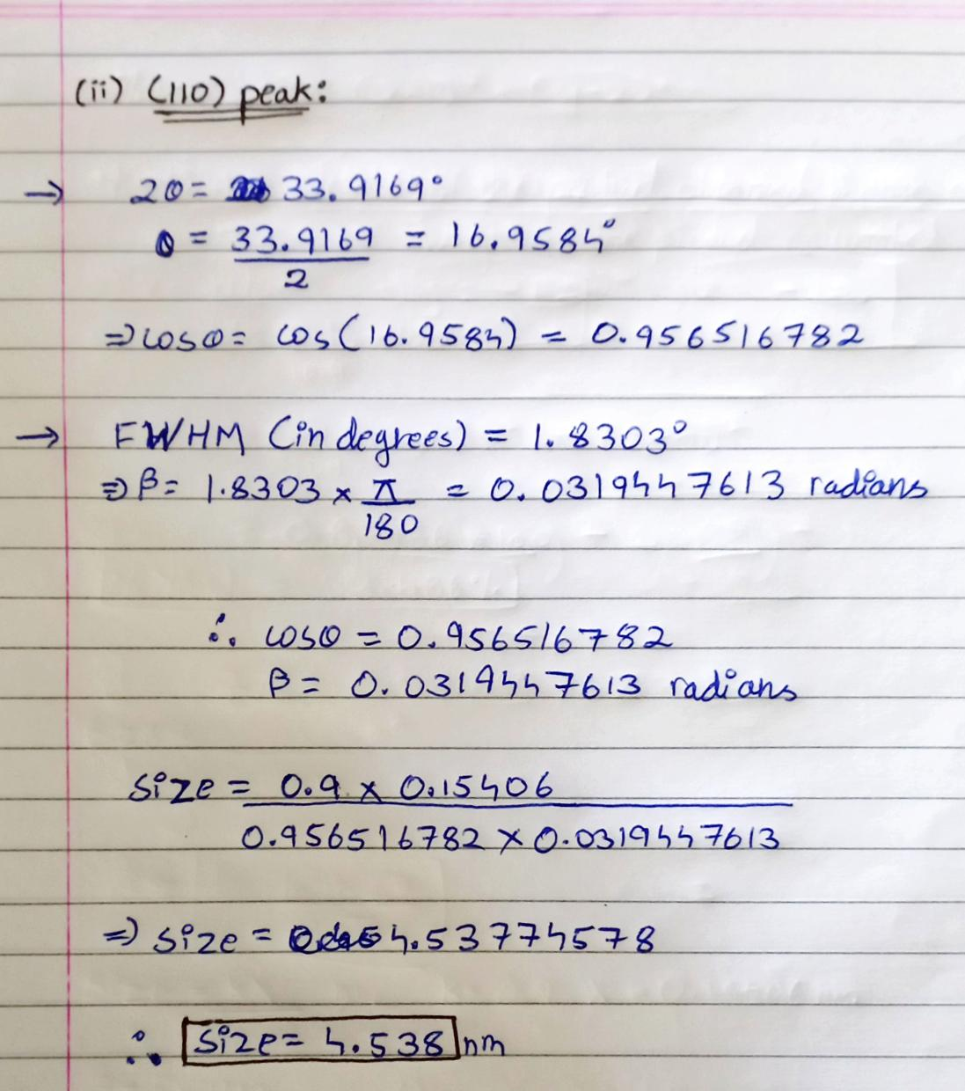 Crystallite size = **4.538 nm**

**Result:**

**(i) The powder XRD peak positions for the prepared by SnO2 nanoparticlesare:**

1. **(110) peak – 27°**
2. **(101) peak – 34°**
3. **(200) peak – 38°**
4. **(211) peak – 52°**
5. **(112) peak – 65°**

**(ii) Particle size/ crystallite size:**

1. **(110) peak – 3.086 nm**
2. **(101) peak – 4.538 nm**